- Open a Web browser and go to the TEAL login page https://tealprod.tea.state.tx.us/
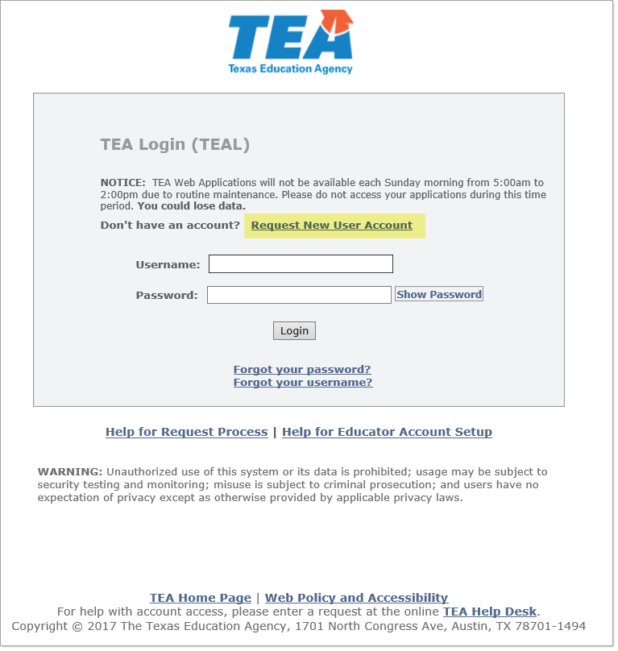

- Click Request New User Account. The user registration page appears.
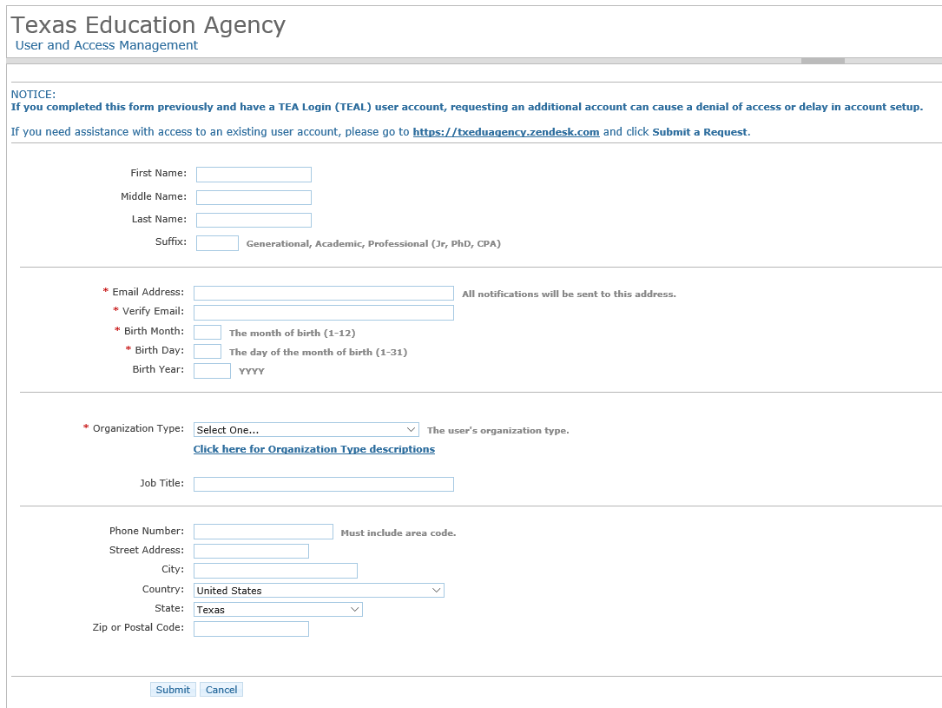

Completing the User Information
The following fields are required: First Name, Last Name, Email Address, Verify Email, Birth Month, Birth Day, and Organization Type.
Use the Tab key to move from one box to the next.
- Type your first, last, and if you wish, middle name.
- Type any suffix, such as Jr. or an academic or professional suffix.
- Type your e-mail address. This address will receive all notification e-mails, including the user access information that you need to log in.
Note: | Do not use a group e-mail address. The address you enter here will receive confidential information for accessing TEA applications. Using a group e-mail address could compromise security for your organization's confidential data.
- Retype your e-mail address to verify that the address is correct.
- Type your birth month and day. This information is used internally to help distinguish you from other users with the same first and last name and is not used for any other purpose.
- Type your birth year.
- Select “District, Charter, ESC, Private School Staff” for the organization type.
- Type your job title.
- Type your phone number, including area code.
- Type your mailing address.
- Check the information you provided to make sure it is correct.
- Click Submit.
- A message appears acknowledging your request. Click Done. The page redirects to the TEAL login page.

Next Steps
You will receive your account information via e-mail.
After initial log on to TEAL, the user must change their password, agree to assurances (every 30 days) and answer security questions:

The user must then request account access to specific TEA Applications.
If a request for account access is not made within 90 days, the TEAL account is inactivated.

